Red Hat Satellite Service:

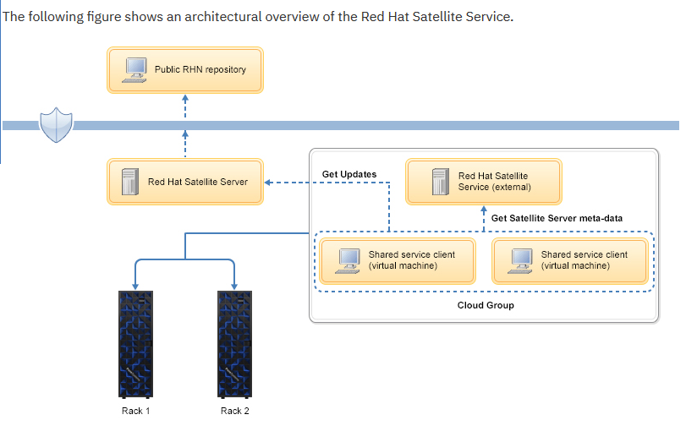

RHUI – Red Hat Update Infrastructure.

Download Entitlement certificate: Red Hat CA certificate

## Makefile on RHUA server

$vi /root/setup/Makefile

$ /gen_rpm_gpgkey.sh

$ /certs/Makefile

$ /etc/rpm/macros.rhel5compat

## RHUA

$ setup/Makefile

$ /answers.txt

$ /certs/Makefile

## CDS

$ /root/setup/Makefile

# make -C setup/

# make -C setup/ certs

# ls setup/certs/

# make -C setup/ genkey

# cat .rpmmacros

## **Install RHUI package:**

# make -C setup/ install-rhua

# make -C setup/

**## Basic Setting of RHUI:**

# cp /etc/rhui/answers.sample /root/setup/answers.txt

# vi setup/answers.txt

# make -C setup genconf

# ls setup/rhui

# rpm --resign setup/rhui/rh-*.rpm

# install -m 644 setup/RPM-GPG-KEY-rhui-custom /etc/pki/rpm-gpg/

# rpm --import /etc/pki/rpm-gpg/RPM-GPG-KEY-rhui-custom

**## Install RHUI configuration package:**

# scp setup/rhui/rh-cds1-config-2.1-2.el6.noarch.rpm root@<CDS#1ホスト名.FQDN>:/root/setup/rhui/

# scp setup/RPM-GPG-KEY-rhui-custom root@<CDS#1ホスト名.FQDN>:/root/setup/

# scp setup/rhui/rh-cds2-config-2.1-2.el6.noarch.rpm root@<CDS#2ホスト名.FQDN>:/root/setup/rhui/

# scp setup/RPM-GPG-KEY-rhui-custom root@<CDS#2ホスト名.FQDN>:/root/setup/

# yum install -y setup/rhui/rh-rhua-config-2.1-2.el6.noarch.rpm

# service pulp-server status

Steps to perform on CDS server.

# install -m 644 setup/RPM-GPG-KEY-rhui-custom /etc/pki/rpm-gpg/

# rpm --import /etc/pki/rpm-gpg/RPM-GPG-KEY-rhui-custom

# yum install -y setup/rhui/rh-cds1-config-2.1-2.el6.noarch.rpm

# service pulp-cds status

# install -m 644 setup/RPM-GPG-KEY-rhui-custom /etc/pki/rpm-gpg/

# rpm --import /etc/pki/rpm-gpg/RPM-GPG-KEY-rhui-custom

# service pulp-cds status; echo $?httpd (pid 5238) is running...goferd (5226) is running.0

**## First time setting of rhui-manager:**

# ls /root/setup/certs/entitlement-ca*

# rhui-manager

RHUI Username: admin

RHUI Password:

rhui (home) => q

**# # Register RHUI Entitlement Certificate:**

# rhui-manager cert upload --cert setup/8a85f98445a9da7b0145b58178897f52.pem

# ls /etc/pki/rhui/redhat/

**## Register CDS:**

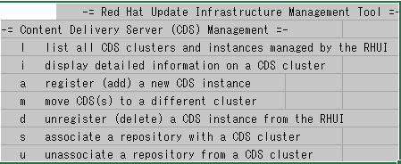

# rhui-manager

rhui (home) => c

rhui (cds) => l

rhui (cds) => a

Proceed? (y/n) y

rhui (cds) => a

Proceed? (y/n) y

rhui (cds) => l

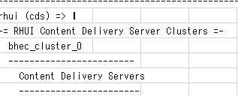

**Note: CDS: Content Delivery Server**

**## rhui-manager**

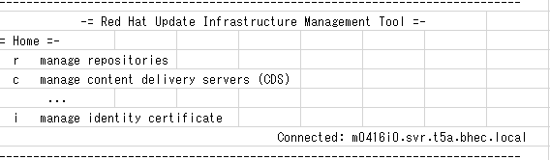

rhui (home) => ｒ

rhui (repo) => l

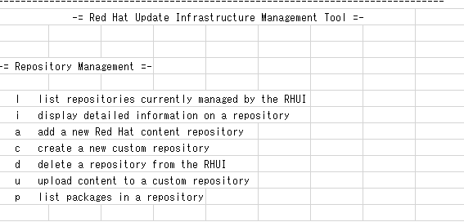

rhui (repo) => a

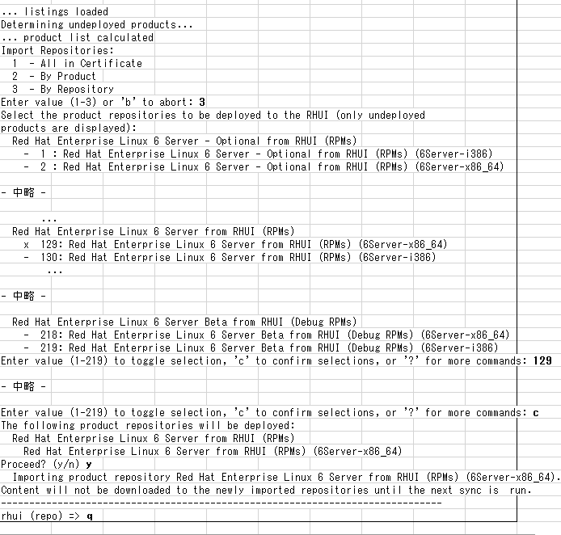

**## Associating Repositories to CDS Clusters:**

# rhui-manager

rhui (home) => c

rhui (cds) => s

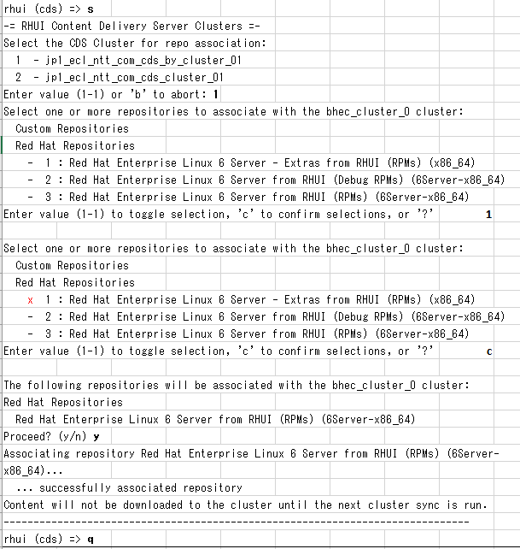

**## Repository synchronization from RHN to RHUA:**

# rhui-manager

rhui (home) => s

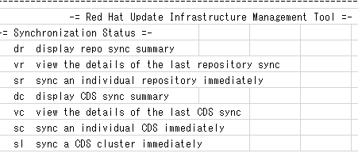

rhui (sync) => sr

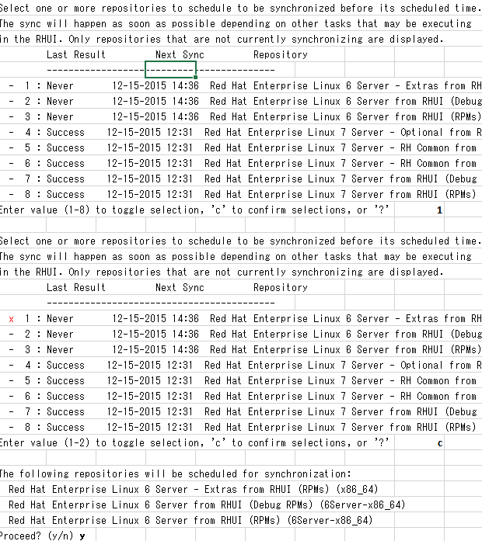

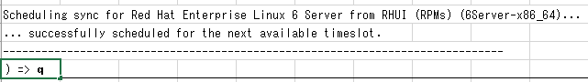

**## rhui-manager**

rhui (home) => s

rhui (sync) => dr

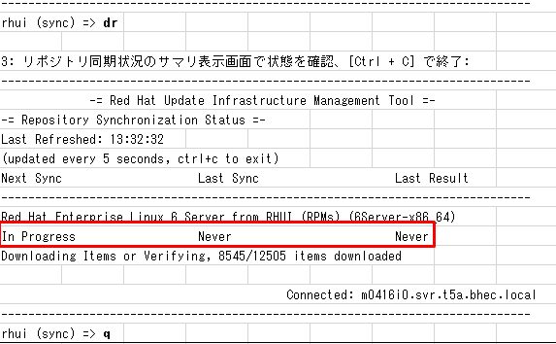

**## Repository synchronization from RHUA to CDS cluster:**

# rhui-manager

rhui (home) => s

rhui (sync) => sl

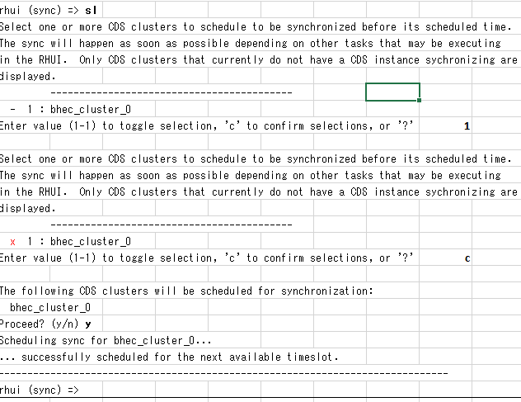

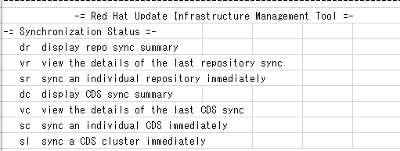

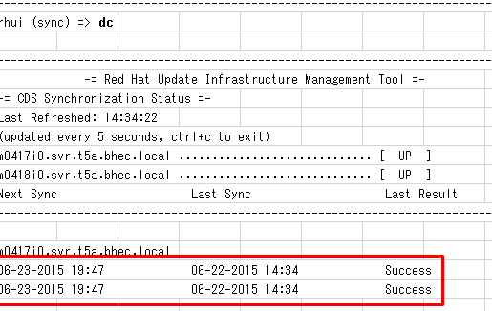

rhui (sync) => ｑ

**## Create RPM package**

# cd /root/setup/clients/

# ls

Rh07-by-rhui-cliento1-test-ap-test.com

# rhui-manager

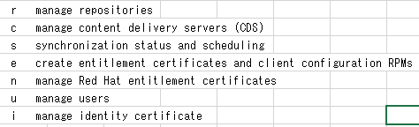

rhui (home) => e

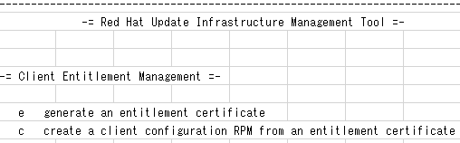

rhui (client) => e



Enter value (1-2) or 'b' to abort: 1

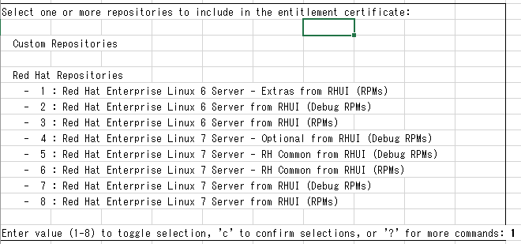

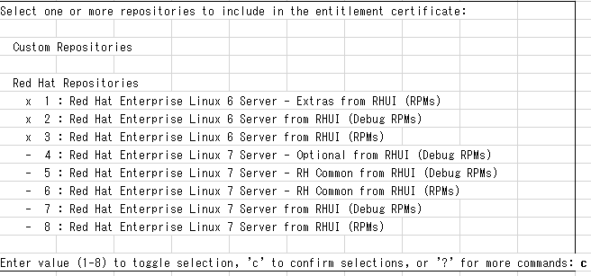



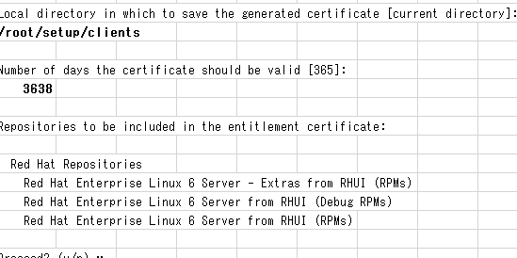





# ls

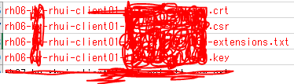

# rhui-emanager



rhui (home) => e

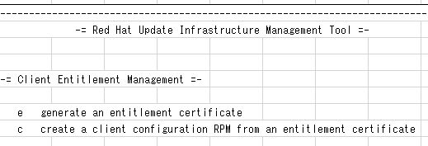





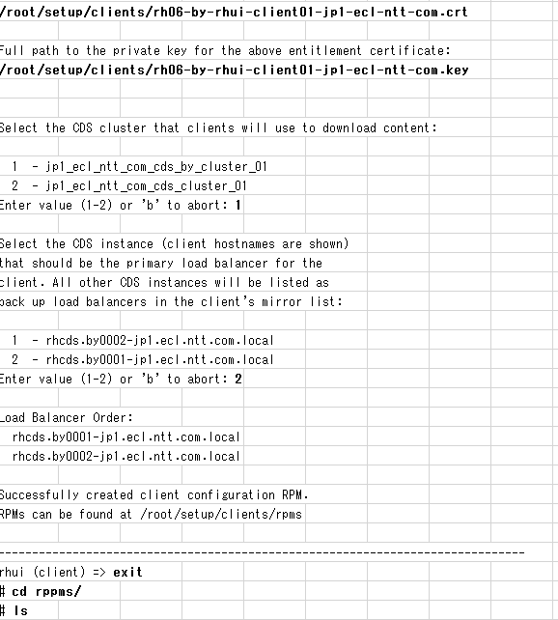

**## RPM package registration and output:**

# rpm --resign /root/setup/clients/rpms/build/RPPMS/noarch/<RPM>.rpm

# rpm --resign /root/setup/clients/rpms/rh06-by



# cp -p /root/setup/clients/rpms/<RPM /<RPM>.rpm /tmp

# cd /tmp

# chown dcadmin:dcadmin <RPM>.rpm

# chmod 777 <RPM>.rpm

# scp dcadmin @ <rhua server IP address>: / tmp / <RPM> .rpm / tmp

# ls -l /tmp